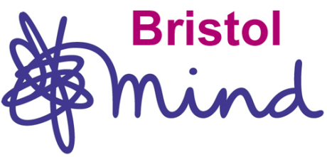
Bristol Mind Outreach Advocacy
35 Old Market Street
Bristol
BS2 0EZ
Tel: 0117 980 0376
Email: advocacy@bristolmind.org.uk
Fax: 0117 929 6587

REFERRAL FORM FOR OUTREACH ADVOCACY
- This service is for people living in the community currently not subject to the Mental Health Act.
- We are an issue-based Advocacy Service; we do not provide general support.
- We do not give advice and cannot complete benefit application forms.
- We only assist people in the local authority area of Bristol (not South Glos or North Somerset Local Authorities)
- Please be aware that the person referred will have access to this form.

Name of client
Address
Tel No
Email

This person has agreed to be referred (please tick)
Please ensure they know that we will be contacting them

Name of referrer
Relationship to client
Contact details
Date
PLEASE EMAIL, POST OR FAX THIS FORM TO US USING THE CONTACT DETAILS AT THE TOP OF THIS FORM
Registered Charity Number: 1085171 Registered Company Number: 04124744

